Code of Behaviour for Leap National School

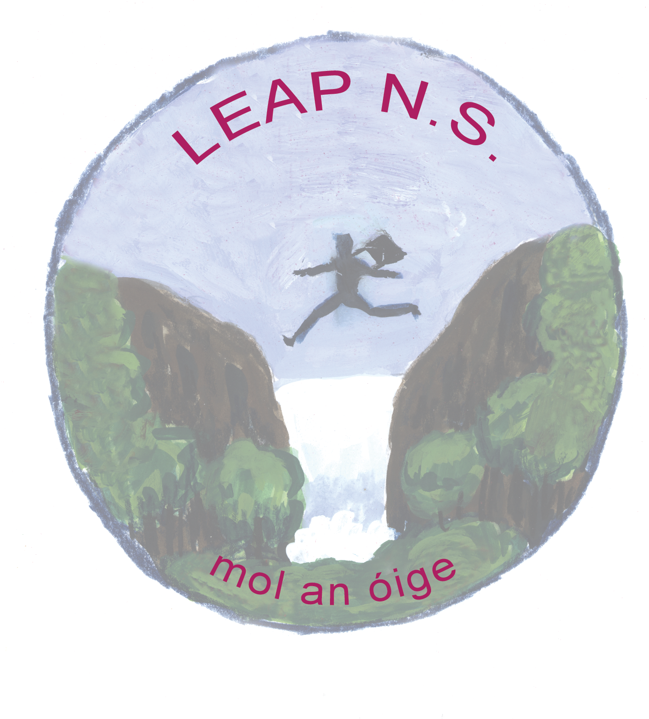

Introductory Statement
This document is a statement of the principles and strategies for managing children’s behaviour in Leap N.S.
This policy is very much a pro-active positive policy: However, it needs to state what behaviours are not acceptable and the sanctions that will be enforced.
It recognises that the vast majority of our students are well behaved.
It works to actively re-enforce and reward this good behaviour.
It recognises the impact poor behaviour has on learning and teaching.

How Our Code was Developed
This Code was formulated in consultation with the staff, Parents’ Association and Board of Management of Leap National School and was developed in accordance with:
- The Education Act 1998, Section 15, (1), (2) Section 21. (1), (3), (4), Section 23, (2), (3)
- Circular 20/90 of the Dept. of Education and Science and Rule 130 of the ‘Rules for National Schools’.
- NEWB guidelines

Our Vision
The vision for relationships and behaviour in Leap National School is that:
‘Each person, through positive learning experiences, will be stimulated to achieve his/her full potential, face life confidently, find fulfilment and be respectful in an ever-changing world.’

Our Mission
Our mission at Leap National School is:
‘To nurture a positive, co-operative and respectful educational environment where each individual values and respects themselves and those around them. Our school community is encouraged to be particularly sensitive to those who have special needs.’
General Guideline for Behaviour in School
All pupils are expected to behave in a responsible manner both towards themselves and others, showing consideration, courtesy and respect at all times. Pupils will respect the rights of others to develop and learn in a secure, safe environment. Respect must be shown for the property of the individual and the school at all times. Each teacher has responsibility for the maintenance of discipline within his/her classroom while sharing a common responsibility for good order within the school premises and grounds. Inappropriate behaviour is not accepted and the class teachers or supervising teacher may impose a sanction as required. Positive behaviour is expected, encouraged and acknowledged. Parents are expected to work in co-operation with the school in implementing the Code of Behaviour.
Our Aims
- To provide for the effective and safe operation of the school.
- To provide guidance for teachers, pupils, and parents on behavioural expectations.
- To develop pupils’ self-esteem and to promote positive behaviour.
- To foster the development of a sense of responsibility and self-discipline in pupils based on respect, consideration and tolerance of others.
- To foster caring attitudes to one another and to the environment.
- To facilitate the education and development of every child.
- To enable teachers to teach without disruption.

Our School Motto
‘Happy children Learning in a Safe Environment”

Our School Rules
- Be Gentle
- Be kind and helpful
- Don’t hurt people’s feelings
- Be honest
- Work hard
- Look after property
- Listen to people

How we promote positive behaviour
In Leap National School we promote positive behaviour by:
- Leading by example – ensuring all pupils are treated respectfully, equally and fairly;
- Ensuring all children are aware of the school rules;
- Having a quiet word or giving a simple gesture to show approval in front of peers;
- Making a positive comment on a child’s effort / exercise book / work;
- Praising in front of class group;
- Giving individual class merit awards, point awards or award stamps/stickers;
- Delegating some special responsibility or privilege;
- Sanctioning a visit to another class or Principal for commendation;
- Writing or verbally communicating with parent to acknowledge exemplary positive behaviour;
- Presenting a green card to the child (See note on Stop, Think, Do Programme[1]);
- Awarding a token to the best behaved line on the schoolyard;
- Implementing ‘Walk Tall’, ‘RSE’, & ‘Stay Safe’ to promote positive behaviour;
- Small treats may occasionally be given as rewards on Fridays.
Rewards
Rewards are recognition of good behaviour, worthwhile work and effort. Some of the following are used as rewards.
- Verbal praise;
- Public acknowledgement of good behaviour by the class teacher or by the Principal;
- Stars, stickers, certificates acknowledging good behaviour;
- Communication to parent;
- Child is sent to another teacher/Principal for additional praise;
- Child chooses favourite activity;
- Class treat or group treat;
- Credits and/or quality stamps
- Small treats are occasionally given as reward

Expectations of Pupils
Expected pupil behaviour in relation to attendance, punctuality, class entry and exit
- School begins for all pupils at 9.20 am. However, Junior Infants commencing school attend at the following times for the first week:
    - Day 1 – Day 10 9.20 am – 12:00 pm
Thereafter, they attend from 9.20 am to 2.00 pm.
All pupils are expected to:
- be punctual and on time;
- attend school daily unless they are sick;
- bring a note to explain absences;
- wear the appropriate school uniform when attending school;
- wear runners and tracksuits on P.E. day and for school trips/ tours.
- line up with their class when the bell rings;
- walk with their teacher in an orderly line into and out of the classroom; and
- remain in their line at home time until the teacher gives permission to leave the line.

Expected pupil behaviour in the general school environment
For reasons of safety and to minimise the potential for accidents, pupils are expected:
- to walk when moving around the school – running, skipping, jumping, hopping etc. is not permitted on corridors or in classrooms;
- not climb on the school railings;
- to show respect for school property at all times;
- to be courteous to others at all times;
- to enter and leave the school building at all times in an orderly fashion. When the bell rings after play-time, children are expected to walk to their class lines;
- not to enter the school building without getting permission from teachers;
- never to bully any person; any behaviour that interferes with the rights of others to learn and to be safe is unacceptable. Fighting, rough play or any physical force is never allowed or tolerated.

Expected pupil behaviour in the classroom
Courtesy and respect for others is the basis for classroom behaviour. Pupils are expected to:
- respect the right of others to learn in a secure safe environment/atmosphere;
- co-operate with instructions given by the teacher;
- complete assigned homework, which may be oral/written, memorisation, or other tasks. Written work will be in a neat and presentable form;
- bring to school each day the books, copies, pens, pencils etc. necessary to do their work properly.
- take proper care of the above items and other personal belongings.

Expected pupil behaviour in playground
Friendship, gentle play and fairness are promoted in the playground. Pupils are expected to:

- recognise the rights of all children in the playground;
- refrain from engaging in any behaviour which endangers themselves or others – behaviours such as climbing, hitting, pushing, kicking etc. are not permitted at any time;
- refrain from engaging in any behaviour which interferes with other children at play e.g. taking a ball or other play item, disrupting the games of others, hitting, kicking, pushing, pulling etc.;
- remain within playground boundaries during breaks;
- only take soft footballs onto the yard during breaks.

Expected pupil behaviour relating to health and hygiene
Pupils are encouraged to take responsibility for personal health and hygiene. They are expected to:
- wear their full school uniform;
- keep their hair neat. For hygiene purposes long hair must be tied back;
- not to wear make-up;
- value our school environment. The school premises and playground are litter-free zones. All empty drink cartons/containers and wrapping papers are considered household waste and must be taken home;
- bring nutritious lunches to school. They should not bring in crisps or other snack packets, sweets, chewing gum or fizzy drinks;
- bring home all personal waste for recycling e.g. wrappers, empty cartons etc.
- wash their hands thoroughly and sanitise in accordance with public health advice regarding minimising the risk of spreading the corona virus
- observe coughing and sneezing etiquette as directed by public health guidelines regarding minimising the risk of spreading the corona virus

Expected pupil behaviour relating to property and personal possessions
- Pupils are encouraged to take care of their personal belongings required for school work i.e. books, copies, uniform etc. However, they are discouraged from bring other personal belongings to school.
- To minimise the risk of the introduction and spreading of the corona virus, pupils may not share personal items with others e.g. pencils, pens, rulers etc.
- To minimise the risk of the introduction and spreading of the corona virus, children may not bring personal belongings to school

Expected pupil behaviour relating to respect and good manners
In Leap National School we seek to support children in developing their social and citizenship skills. To this end pupils are expected to:
- use polite language when greeting, requesting and thanking peers and staff;
- refrain from using inappropriate or bad language. The use of such language during the school day either within the school or on a school activity is considered a very serious breach of this Code of Behaviour;
- treat themselves, each other and all staff members with due respect and courtesy;
- stand back for an adult, to welcome visitors and to show respect to their elders;
- respect the school building and property. If deliberate damage is caused, the parent/guardian will be responsible for the cost of repair/replacement;
- walk within the school building quietly and calmly.

Expected pupil behaviour on wet days
On wet days, at break time, children are expected to:
- eat their snack/lunch and to remain in their class, or appointed class, and engage only in activities as instructed by the class teacher or supervising teacher;
- be respectful at all times to the supervising teacher, who will move around all the classrooms throughout the break time period;
- engage with their activities in a calm, orderly fashion; they should remain in their classroom and should not engage in running, jumping, hopping etc.;
- refrain from using a tin-whistle or other instrument, these are only allowed during music lessons ;
- refrain from touching/using scissors, compasses, rulers and other school work objects – these are only to be used when a teacher is in the classroom and instructs the children to do so.
Expected pupil behaviour when swimming
When possible, the school provides for swimming instruction as part of the Physical Education Programme. When going swimming pupils are expected to:
- walk in line behind the teacher to the swimming pool. No running allowed;
- never shout or run in the dressing rooms or pool area;
- listen and obey the instructor and life guard;
- wear a swimming cap. Arm bands may be needed for beginners and shower socks may be worn;
- use the steps when entering and exiting the pool;
- never push or play roughly in the pool, pool area or dressing rooms;
- dress quickly after each session;
- bring no hairsprays, gels, spray deodorants to the pool; Roll-on deodorants are allowed for 4th – 6th class pupils;
- buy no drinks/sweets at the pool.
At Leap National School we endeavour to provide a wide a range of learning opportunities for children. This includes trips, tours and excursions to out of school sites and activities. When on these trips pupils are expected to:

Expected pupil behaviour when on school tours/trips/excursions
- wear their P.E. uniform;
- arrive 15 minutes before departure time; Parents are expected to contact the school 15 minutes before departure time if a child is sick or unable to attend. The bus will not wait longer than the departure time given;
- enter/leave the bus in an orderly manner;
- remember, school rules apply to school trips;
- not to bring mobile phones and/or other electronic devices on school tours; Teachers will have mobile phones on tour if parents/children need to get in contact with one another;
- sit in their seats, with seatbelt on and avoid loudness that would distract the driver;
- take drinks and sweets at the appointed lunch breaks;
- stay in their appointed groups at all times;
- follow teacher instructions at all times.

Sanctions
Breaching of this Code of Behaviour will result in sanctions; the degree of the sanction will depend on the nature and number of the misdemeanour(s).
In imposing a sanction it is the misbehaviour which is targeted, not the individual. The child is encouraged to consider the inappropriateness of his/her behaviour, the consequences of his/her behaviour and how they may have changed their action to achieve a more positive outcome. When misbehaviour occurs the following is a list of possible sanctions or strategies used. This is not exhaustive.
The relevant teacher or teachers will decide on the relevant sanction(s) for minor misdemeanours. The Principal will decide on the relevant sanctions for serious and extreme misdemeanour(s)

Examples of minor misdemeanours:
- Boisterous play- hitting, pulling, shoving, pushing, tripping, spitting
- Interrupting class work
- Failure to follow instruction
- Being discourteous/unmannerly- name calling, giving cheek, rude comments, jeering
- Telling ‘white’ lies
- Stealing items belonging to peers/classroom e.g. rubber, pencil, toys
- Not completing homework without good reason and/or without a note from parents/guardians;
- Arriving late for school
- Leaving seat without permission
- Not wearing correct uniform
- Running in school building
- Leaving litter around the school
- Failing to line up properly or misbehaving in the line

Sanctions for minor misdemeanours
- Verbal reprimand/making the pupil aware of the fact that his/her behaviour is unacceptable
- The seating arrangement in the class may be changed
- Temporary separation from peers
- Principal called in to speak with the class as a whole about what behaviour is expected in school.
- The pupils may be asked to write an account of what happened and how they should have behaved – to be signed by parent/guardian.
- Note in homework journal to be signed by both parents/guardians

Examples of serious misdemeanours
- Constant repetition of minor misdemeanours (i.e. no improvement following intervention)
- Stealing of school property e.g. money, CD’s, DVD’s
- Bullying (See separate Anti-Bullying Policy)
- Ganging up on, picking on, deliberately hurting or interfering with another pupil e.g. writing a note about another child, kicking a ball at a child intentionally
- Telling serious lies e.g. that the lie may directly/ indirectly effect a person(s)or the outcome of a situation(s)
- Constantly disruptive in class- cheeky, distracting others, constantly talking
- Defiance/ disrespect towards a teacher
- Over boisterous play- Kicking, punching, fighting, dragging
- Using unacceptable or inappropriate language
- Seriously damaging another pupil’s property
- Graffiti on school property
- Deliberately coughing or sneezing into another child’s/staff members face

Sanctions for serious misdemeanours
- Removal from activity which he/she is involved in
- Inclusion of the details in School Incident Book
- Withdrawal of privileges (e.g. special treats including school tours, sailing lessons)
- Child referred to the Principal
- Parents called in to speak with class teacher and/or principal to resolve the issues and avoid any repetition
- Supervised detention during one or more breaks
- Repeated actions (e.g. forms of rough play) that could lead to injury and that continue after an initial correction will be brought to the attention of the relevant parents/guardians

Examples of extreme misdemeanours
- Repeated serious misdemeanours (i.e. no improvement following intervention, sanctions etc.)
- Harassment, discrimination, victimisation
- Seriously and/or sudden aggressive, threatening and/or violent behaviour;
- Physical hurt to another person
- Extreme damage to school property
- Leaving school premises during school hours without permission

Sanctions for extreme misdemeanours
- Safety of all is established e.g. removal of children who are in danger
- Contact established with Parents/Guardians
- Supervision or Removal of offending pupil from the school pending a proper investigation
- Use of one or more of the sanctions from the list for “Sanctions for serious misdemeanours”
- Suspension
- Expulsion

Should an ongoing behaviour problem arise the following procedures are followed:
- At the onset of the behaviour, the class teacher / teacher in charge deals with it and may impose a sanction.
- If the problem is not solved, and the behaviour continues, the class teacher shall consult the Principal and / or the parents / guardians of the child with a view to helping the child overcome the difficulty. The National Educational Psychology Service (NEPS) Guidelines for Teachers for Behavioural, Emotional and Social Difficulties will apply.
- If the problem persists or in the case of serious misbehaviour the Principal may ask the parents/guardian to attend a meeting, with the aim of discussing the problem and putting in place strategies to help the child overcome the problem behaviour.
- Should the problem continue, additional meetings and interventions may be called for to monitor the situation, always with the objective of helping the child.
- If the problem continues it may lead to referral to the NEPS Team and/or suspension or expulsion.

Suspension
Suspension will be in accordance with the terms of Rule 130 (5) of the Rules of National Schools. Before resorting to serious sanction e.g. suspension, the normal channels of communication between school and home will be utilised. The school principal has the authority to sanction a 3 day suspension. Further progressive suspensions will require Board of Management approval. This approval may be obtained at a regular meeting of the Board or at an emergency meeting at which the chairperson and principal have outlined for the Board the reasons why they feel it is necessary to impose a further progressive suspension. In line with the requirements of the Education Welfare Act (2000), the Board of Management will inform the Education Welfare Board when a pupil’s period of suspension equals or exceeds six school days or results in the pupil exceeding 20 days of absence in a school year.
Removal of suspension (Reinstatement)
Following, or during a period of suspension, the parents/guardians may apply to have the pupil reinstated to the school. The parents/guardians and the pupil must give a satisfactory undertaking that the suspended pupil will behave in accordance with the school code and the principal must be satisfied that the pupil’s reinstatement will not constitute a risk to the pupil’s own safety or that of the other pupils or staff and will not have a seriously detrimental effect on the education of other pupils. The principal will facilitate the preparation of a behaviour plan for the pupil, if required, and will re-admit the pupil formally to the class.

Expulsion
The Board of Management has the authority to expel a pupil in an extreme case e.g. where repeated incidents of serious misbehaviour interfere with the education opportunities of fellow students or where there is a threat to the health and safety of other students or staff. Where expulsion is considered, the school authorities will have tried a range of other interventions and will have formed the opinion that they have exhausted all possibilities for changing the pupil’s behaviour. This sanction would be imposed under the terms of Education Welfare Act (2000). Suspension/expulsion procedures are in accordance with the Education Act (1998) The school will at all times endeavour to adhere to the guidelines as set out in Developing a Code of Behaviour: Guidelines for Schools
http://www.newb.ie/downloads/pdf/guidelines_school_codes_eng.pdf
Supporting the Code of Behaviour
Expectations of Staff
Education
- Support and implement the school’s code of behaviour
- Be cognisant of their duty of care
- Facilitate pupils to reach their full academic potential

Health and Safety
- Be familiar with and follow the school’s policy on “Child Protection”.
- Be familiar with the school’s “Professional Conduct Code”
- Create a safe, welcoming environment for each pupil

Communication
- Praise desirable behaviour
- Recognise and provide for individual talents and differences among pupils
- Be courteous, consistent and fair
- Keep opportunities for disruptive behaviour to a minimum
- Deal appropriately with misbehaviour
- Keep a record of serious misbehaviour or repeated instances of misbehaviour
- Listen, at appropriate times, to pupils’ explanations for behaviour
- Provide support for colleagues
- Communicate with parents and staff when necessary, always with courtesy and respect
- Provide reports on matters of concern.

Expectations of Parents
We look forward to working closely with you as a parent/guardian and in the interest of ensuring your child has a happy, fulfilling and successful educational experience during their primary years, we would encourage you to:

Education
- nurture in your children a positive attitude towards school and try not to pass on any negative experiences you may have had yourself while at school;
- be interested in, support and encourage your child’s school work;
- be familiar with this Code of Behaviour and other school policies and support the implementation of these policies;
- ensure that you child has the correct books and other materials;
- ensure they wear the appropriate school uniform, arrive punctually for school and are collected on time.
- In line with the school’s Homework Policy, homework is assigned by the class teacher to reinforce work completed in class. Homework may be given Monday – Thursday. Homework is not given at weekends. The time taken to complete homework will vary from child to child but a general guide is:
- Infants 10 – 15 minutes
- 1st & 2nd Class 20 – 30 minutes
- 3rd & 4th Class 30 – 40 minutes
- 5th & 6th Class 40 – 60 minutes
If your child is experiencing difficulties with homework or taking longer to complete tasks than is advised please inform their class teacher. Parents can support their child by ensuring a routine is established for homework completion, a quiet work area is used and children are not distracted. Children from 1st – 6th class will have homework diaries and parents should sign these to confirm that the work has been fully completed. Parents can communicate any questions, issues or problems which may arise relating to homework by putting a note in the diary or arranging to meet the teacher at a mutually convenient time. You are advised to encourage your child to ensure their pencils are sharpened and they have all they need in their pencil cases and bags, for the next day, as part of their homework routine.
- During swimming lessons no parents are permitted to the poolside. 2 Parent volunteers are asked to attend before and after the lesson to assist the junior and senior infant children with dressing
Health and Hygiene
- ensure your child attends school regularly and punctually in full school uniform[2] with appropriate clothing for the weather so that your child will be warm and dry playing outside during breaks;
- check your child’s head regularly for head lice and treat as necessary. Please inform the class teacher if your child has head lice;
- ensure your child has clean hands and nails, good toileting habits and is able to use tissues;
- ensure their child gets adequate sleep each night;
- ensure your child has a healthy lunch in school every day in line with the school policy on “Health Eating“- treats such as a small chocolate bar, a biscuit are only allowed on a Friday. Our school operates a programme to encourage pupils to reduce, re-use and recycle waste. We ask that parents support this initiative and use lunch boxes and re-usable plastic bottles for drinks. All wrappers must be brought home by the children.
- ensure your child does not attend school if he/she is sick. Children are encouraged to use the yard at break time and cannot stay in unless their safety is compromised e.g. limb in cast. If a child is well enough to attend school they are well enough to use the yard at break times;
- ensure all your child’s property is clearly labelled e.g. individual items of clothing, school bag, pencil case, books, copies etc. Items of clothing should be clearly labelled in permanent marker with your child’s first and second name.
- If your child has a specific medical condition or is on any medication inform the class teacher in writing.
- If a parent wishes for their child to receive medication during the school day they may call to the school (or appoint a designated person) to administer the required medicine in the course of the day. Staff members are not authorised to administer medicine except in life threatening situations or where that staff member has been sanctioned to do so by the Board.
- No smoking is allowed on the school grounds at anytime.
Communication
  - ensure the school has up-to-date phone numbers of family/friends to be contacted in case of an emergency.
  - arrange and ensure that a family member/friend is contactable and available to attend the school in the event of an emergency.
  - arrange meetings with the class teacher and/or principal if you are concerned about any issue relating to your child;
  - communicate with staff when necessary, always with courtesy and respect and model good behaviour in your relationship with teachers
  - visit the school when requested to do so
  - co-operate with teachers to help your child in instances where your child’s behaviour is causing difficulties for others.
  - If circumstances arise where your child is late for school and arrives after 9.20am you must accompany your child and give an explanation for lateness to your child’s teacher.
- School finishes for Junior and Senior Infant classes at 2pm and for 1st – 6th classes at 3 pm. Should you need to withdraw your child before school finishes you may do so by calling to your child’s classroom door and give an explanation for the early finish to the teacher.
- All absences from school should be explained to the class teacher in writing by a parent/guardian. A record of all absences is maintained by the school. The effect of absences on a child’s progress and behaviour will be documented. Under the Education Welfare Act (2000), the school is legally bound to report to the Welfare Board any child who is absent from school for 20 days or more. Where there is no justifiable reason parents are liable to prosecution by the Welfare Board.
- The Board of Management, Principal and Staff of Leap National School reserve the right to modify details of this Code at short notice to deal with matters that were not foreseeable when the code was drafted.
- This Code will be reviewed on a yearly basis.

Declaration of Acceptance of Leap National School’s Code of Behaviour
(Please complete in Block Capitals)
Pupils Name: Date of Birth (DOB)
Pupils Name: Date of Birth (DOB)
Pupils Name: Date of Birth (DOB)

Name of Parent/Guardian (1): ______________________________________
Name of Parent/Guardian (2): _______________________________________
I (we) confirm that I (we) have been given a copy of the Code of Behaviour for Leap National School; that I (we) have read and understand the Code; and that I (we), as a parent/guardian (parents/guardians) accept and agree to support this Code of Behaviour while my (our) child is attending Leap National School.

Signed: Parent/Guardian (1): _____________________________________________
Signed: Parent/Guardian (2): _____________________________________________
Date: _______________________________________
[1] Stop, Think, Do is a social skills programme where children are encouraged to think before they act. Our aim is to teach children to take time and to think when faced with choices or presented with difficult situations. Through this approach children learn that they are responsible for their own actions. Good choices are acknowledged rewarded with a green card. Bad choices/decisions receive a yellow (warning) card – a reminder to stop and think – or a red (forbidden behaviour) card – an indication that your chance to rectify your behaviour has passed and you have lost the privilege of decision-making.
[2] All children are required to come to school in their school uniform. The school uniform is as follows: Boys: Navy trousers, navy jumper, blue shirt. Girls: Navy trousers/pinafore/skirt, navy jumper, blue shirt. School jumpers can be purchased through the Parents’ Association.
All pupils should wear runners and tracksuits on P.E. day and for school trips/ tours. Class teachers will inform parents of the days on which pupils will have P.E. Children who are not wearing runners will not be allowed to participate in PE lessons on Health & Safety grounds.
This policy and its implementation will be reviewed by the Board of Management once in every school year. Written notification that the review has been completed will be made available to school personnel, published on the school website and provided to the parents’ Association.

Signed: ____________________________________ Signed: _______________________________
Chairperson of board of Management Principal

Date: ________________________ Date: _____________________________

Date of next review: ________________________________

