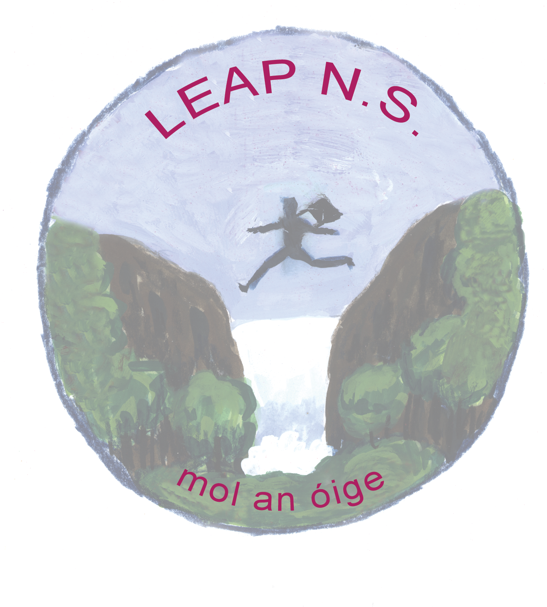
Leap N.S.
Book Rental Scheme Policy
Rationale:

In the present economic climate we are hugely aware of the importance of keeping school costs to a minimum. The book rental scheme saves parents a lot of money, especially in the long term, as the child progresses up through the school. The scheme is operated by the school staff on behalf of the Board of Management with occasional assistance from parent volunteers.

Benefits to a Book Rental Scheme:
There are many benefits for both parents and pupils;
- The scheme will greatly reduce the amount of money spent by parents each year on books.
- Parents no longer have to go through the hassle of purchasing and covering books.
- All schoolbooks including workbooks will be provided by the school on the first day of the year.
- As the school is buying in bulk, there will be a significant discount on price.
- All pupils will have access to a much wider range of textbooks, as the school will purchase additional class texts.

Timeframe:
The scheme began operation for the school year 2014/2015. The Board of Management provided funding for the scheme initially and was subsequently reimbursed by fees raised from parents and the D.E.S. Book Grant of that year.

Main Points of the Scheme:

The scheme is compulsory.

The parents are charged a fixed sum each year to participate in the book rental scheme. This money is then used to buy /cover /supplement /replace sets of books for the class which are used by children in the school. With careful management these books can last for many years. They are normally replaced because the books are out of date rather than because of the condition of the books, once the books are treated with respect and care

A rental charge of €10 per year for J.I. to 2nd class and €30 per year for 3rd to 6th classes will apply. The payment of this charge will secure the rental of all relevant textbooks as and when required throughout the school year.

The school will also purchase the necessary workbooks for each pupil for the year. This will ensure that all pupils have the necessary books in school from the first day of the school year. Parents will be charged for these workbooks at the same time as book rental and photocopying fees.

Purchase of copies, disposable materials and stationery will remain outside the scope of this scheme and remain the responsibility of the parents.

To qualify for admission to the scheme and to ensure each child has the necessary books from the first day of school, the rental charge, workbook fee and photocopying charge must be paid on or before the first day of the school year.

Each parent/guardian will be required to read, accept and sign the book rental scheme terms and conditions which will be retained in the school.

The books supplied under the scheme will remain the property of the school and may be subject to inspection at any time by a member of the teaching staff.

Membership of the scheme is at the discretion of the board of management and the school principal. Any pupil found to be abusing, defacing or disposing of rented books will be dismissed from the scheme and will be required to supply their own textbooks for the remainder of their time in the school.

Books supplied under the scheme may be new or second hand at the discretion of the principal and board of management.

Timeline for managing the book rental scheme:

Term Three (April – June)
- Parents are requested to donate or sell second-hand books to the scheme
- Final book lists are compiled
- The final retail cost of books is obtained
- The rental charge is determined for each pupil/student
- Decisions are made regarding the inclusion of copies, student diaries and/or other materials in the rental fee
- Rental forms are distributed with a definite date for return
- A note is sent to students to check the condition of books to be returned to the scheme
- Previous years’ books are collected
- The condition of books is checked by the school
- Stock is checked and a decision is made on how many new books to purchase
- New and second-hand books are ordered, delivered and covered
- Books are labelled with the school stamp
- A suitable database may be used to track and record the book rental scheme
- Books are divided into packs for distribution and stored over the summer period in the school

Term One (August – December)
- Book rental forms are sorted and filed
- Book deposits/fees are collected
- Each child’s name label is placed on the books
- Books are distributed to students and a record is maintained
- Students and parents are reminded that the books are the property of the school and of best practice regarding care and maintenance of the books.

Maintenance:
- Pupils are responsible for all textbooks issued to them by the book rental scheme and are actively encouraged to take proper care them.
- Pupils should handle them with care. Pen and pencil marks, water damage or torn books will not be accepted and must be replaced.
- All text books are covered with clear plastic covers.
- Small labels with the child's name will be applied to the books by the school. Parents/pupils are not permitted to write their name on the book in any other place.
- No sellotape or staples are permitted on the books.
- Teachers also have a vital role to play in the proper care and condition of the textbooks.

Return of Books:
- When books are finished in each class, they are returned to the school.
- A date is decided with the Principal as to the last date for all book returns and parents/pupils will be informed in advance of this date.
- The cost of lost, damaged or unreturned books is borne by the parents.

Policy Ratification
Signed on behalf of the Board of Management:

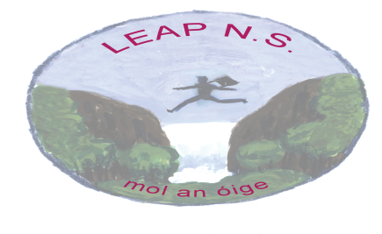
SCOIL AN CHROÍ NAOFA
(Leap National School)

Leap

Co. Cork
Phone: (028) 33574

Email: leapns.ias@eircom.net Roll No: 11245R
Website: www.leapnationalschool.ie

RE: School Book Rental Scheme-Arrangements

Dear Parents/Guardians,

In the present economic climate we are hugely aware of the importance of keeping school costs to a minimum. The book rental scheme saves parents a lot of money, especially in the long term, as the child progresses up through the school. The scheme is operated by the school staff on behalf of the board of management with assistance from parent volunteers when requested.

- The scheme is compulsory.
- The parents are charged a fixed sum each year to participate in the book rental scheme. This money is then used to buy /cover /supplement /replace sets of books for the class which are used by children in the school. With careful management these books can last for many years. They are normally replaced because the books are out of date rather than because of the condition of the books, once the books are treated with respect and care
- A rental charge of €10 for J.I. to 2nd class and €30 for 3rd to 6th classes per year will apply. The payment of this charge will secure the rental of all relevant textbooks as and when required throughout the school year.
- The school will also purchase the necessary workbooks for each pupil for the year. This will ensure that all pupils have the necessary books in school from the first day of the school year. Parents will be charged for these workbooks at the same time as book rental and photocopying fees.
- Purchase of copies, disposable materials and stationery will remain outside the scope of this scheme and remain the responsibility of the parents.
- To qualify for admission to the scheme and to ensure each child has the necessary books from the first day of school, the rental charge, workbook fee and photocopying charge must be paid on or before the first day of the school year.
- Each parent/guardian will be required to read, accept and sign the book rental scheme terms and conditions which will be retained in the school.
- The books supplied under the scheme will remain the property of the school and may be subject to inspection at any time by a member of the teaching staff.
- The cost of lost, damaged or unreturned books is borne by the parents.
- Membership of the scheme is at the discretion of the board of management and the school principal. Any pupil found to be abusing, defacing or disposing of rented books will be dismissed from the scheme and will be required to supply their own textbooks for the remainder of their time in the school.
- Books supplied under the scheme may be new or second hand at the discretion of the principal and board of management.

.
Please complete the attached form and return it with the appropriate amount on the first day of the school year. Cheques should be made payable to “Kilmacabea National School”. Pupils who have not paid the fee by the given date will not be given their books until fees are paid.

