Leap National School
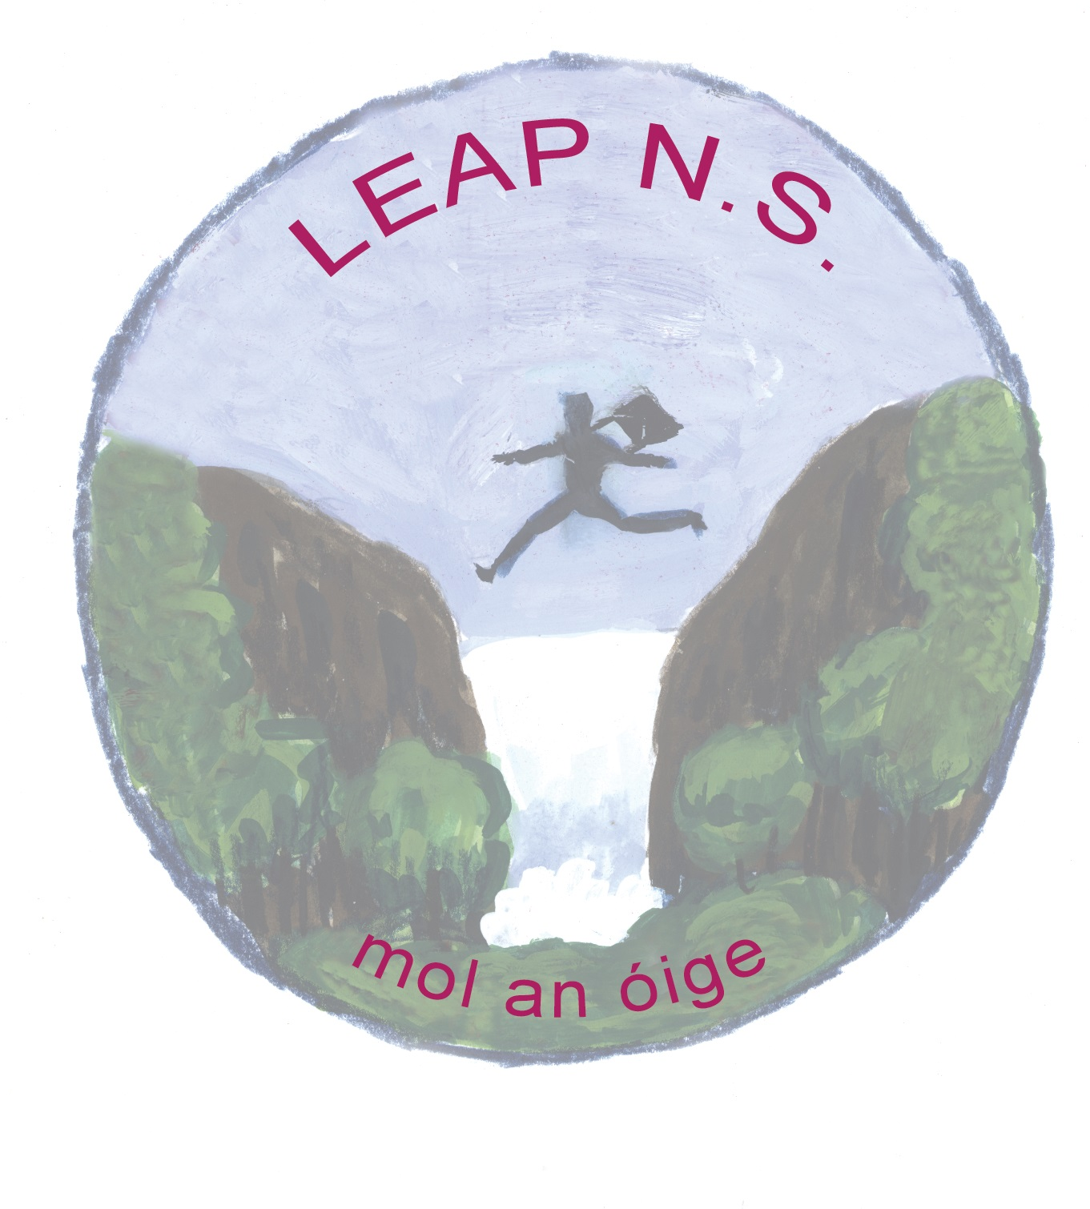
Privacy Notice to students (and their parents/guardians)

By enrolling in and attending Leap National School, you acknowledge that your personal data (including special category personal data) shall be processed by Leap National School.

This Privacy Notice gives you some helpful information about who we are, what personal data we collect about you, why, who we share it with and why, how long we keep it, and your rights.

If you need more information, please see our Data Protection Policy available at Leap National School

- Who we are:

We are Leap National School

Our address and contact details are Kilmacabea, Leap, Co. Cork
Phone: 028 -33574
Email: nationalschoolleap@gmail.com

We provide primary education

For further information, our Data Protection Policy is available at www.leapnationalschool.ie

- The information we collect about you

When you are a student with Leap National School, we collect and use your personal data.

The personal data we collect can include information about your identity and contact details; images/ photo, family details; admission/enrolment details; previous schools; academic progress; PPS number; special educational needs; nationality; language; religion; medical data; information about behaviour and attendance; information about health, safety and welfare; and other personal data.

Further details of the data we collect about you can be found in our Data Protection Policy.

As you are under 18 years when you enrol, we collect the name, address, contact details and other information about your parents/guardians. Your parent/guardian is consulted and asked to give consent for certain things like taking your photograph, going on school trips etc.

- How we use your information and the legal basis

We use your personal data for purposes including:
your application for enrolment;
to provide you with appropriate education and support;
to monitor your academic progress;
to care for your health and well-being;
to care for our staff and students;
to coordinate, evaluate, fund and organise educational programmes;
to comply with our legal obligations as an education body;
to comply with our monitoring and reporting obligations to Government bodies,
to process appeals, resolve disputes, and defend litigation etc.

For further information on what data we collect, why we collect it, how we use it, and the legal basis for same, please go to our Data Protection Policy available at www.leapnationalschool.ie

- Who we share your information with

We share your personal data with third parties, including other Government bodies.

This includes the State Examinations Commission, the Department of Education and Skills, NCSE, TUSLA, An Garda Síochána, HSE, the Department of Social Protection, the Revenue Commissioners etc.

The level of sharing and the nature of what is shared depend on various factors. The Government bodies to which we transfer your personal data will use your personal data for their own purposes (including: to verify other information they already hold about you, etc) and they may aggregate it with other information they already hold about you and your family. We also share your personal data with other third parties including our insurance company and other service providers (including IT providers, security providers, legal advisors etc), We are legally required to provide certain records relating to the progress of a student (under 18 years) in his/her education to the student’s parents/guardians, including results of examinations. For further information on who we share your data with, when and in what circumstances, and why, please see our Data Protection Policy available at www.leapnationalschool.ie.

- We do not transfer your personal data to a third country or international organisation.

- We do not engage in automated decision making/profiling.

- How long we hold your data

Some personal data is only kept for a short period (e.g. we will destroy at the end of an academic year because it is no longer needed). Some data we retain for a longer period (e.g. retained after you leave or otherwise finish your studies with Leap N.S. For further information on the retention periods, please see our Data Protection Policy available at www.leapnationalschool.ie

- You have the following statutory rights that can be exercised at any time:

- Right to complain to supervisory authority.
- Right of access.
- Right to rectification.
- Right to be forgotten.
- Right to restrict processing.
- Right to data portability.
- Right to object and automated decision making/profiling.

For further information, please see our Data Protection Policy available at www.leapnationalschool.ie.

- Contact

Primary Sector:
If you would like to discuss anything in this privacy notice, please contact Mary Crowley at email:nationalschoolleap@gmail.com.

