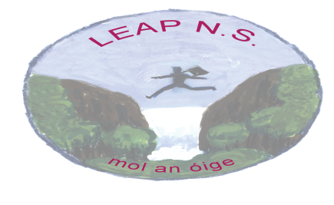

Leap National School

Parental Involvement
Together with staff and pupils, the parents are an integral part of our school community.
We value parent’s involvement in all aspects of school life and rely on parental feedback on policies and activities in order to review and improve.
Below are the general guidelines for Parental Involvement
Guidelines for Getting Involved
- Parents who volunteer to work with school staff during school time agree to undergo Garda Vetting as a matter of course.
- Parents come into the classroom at the invitation of the teacher by prior arrangement and for an agreed purpose.
- The happiness, welfare and safety of our children are our primary concern. A child’s personal history and academic achievements are strictly confidential. Any doubts about issues of confidentiality must be discussed with the teacher.
- Respect for the teachers in their professional capacity is essential.
- Discipline remains the responsibility of the teacher.
- All work will be supervised by the teacher.
- Parents who participate in activities which may include their own child should be conscious of and sensitive to the needs of the entire class, not just the needs of their own child. Where practical parents will be asked to work in a class other than their child’s class.
- Parents coming into the classroom must consult with the teacher before inviting other parents/individuals to participate.
- In the interests of safety, toddlers and younger children not enrolled in the school cannot be accommodated during a classroom activity.
- The highest standard of behaviour and language is expected.
- Punctuality and consistency are crucial.
- No fees are payable.
- In the case of an ongoing project that takes place over a number of weeks, parents will meet with the teacher to discuss the activity. It remains the responsibility of the teacher to determine its appropriateness (e.g. is it suitable for the age group, has something similar already been done etc.). The teacher has the final say in the event that he/she feels it is falling short of its original aims and objectives.
- The school ethos must be adhered to consequently, respect for all the partners in education – children, teachers and parents – must be upheld at all times.

