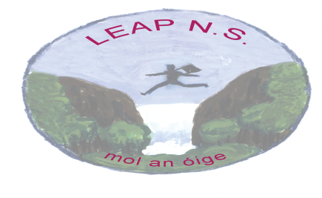

Leap National School

External Coach Policy

The Revised Curriculum P.E. (1999) states “National and local sports organisations may offer to provide coaching of particular sports on a voluntary basis as part of the physical education programme. In the same way, dancers associated with particular projects to promote dance in education may offer to teach dance. In determining the role of any coaches, leaders or dancers the teacher and school should identify the needs of the children gaps in provision extent to which the support personnel will benefit the individual child and class previous experience with young people of the personnel selected
• qualifications of the support personnel and current Garda vetting status
• knowledge of health and safety displayed by the support personnel
• organisational skills of the support personnel.
The class teacher should then discuss with the personnel selected the requirements of the class and of individual children within the class where appropriate, the school’s policy on physical education and the class programme for physical education. The selected personnel can then support the role of the teacher in the implementation of a programme which will benefit the individual child and the class. It is essential that a class teacher be present as the coach works with the class.”

Responsibilities of the External Coach
- Liaise with principal and class teachers regarding the suitability of their expertise vis-à-vis the school plan and individual class plans.
- Work directly alongside a designated class teacher.
- Support the class teacher where competence, confidence, knowledge or skills in teaching a particular activity may be a challenge to them
- Ensure the emphasis is on participation and enjoyment during lessons
- Provide for differing levels of ability
- Take all necessary safety precautions
- Ensure full participation by female and male pupils
- Help to establish community/club links
- Have current Garda vetting through their N.G.B.

Responsibilities of the class teacher:
- Retain overall responsibility for the care and well being of pupils in the class
- Be present throughout the coaching session
- Provide external coaches with information and assistance regarding the needs of the children.
- Adopt an active role in lessons where an external coach is delivering or facilitating.
- Provides and receives feedback from EPs before/during/after PE lessons.
- Develop their teaching skills/content knowledge through active observation and interaction with the external coach
- Evaluate the contribution of the external coach within the context of the class / school plan for PE

Responsibilities of the school principal
- Assesses the suitability of the external coach to work with primary school children by ensuring that the external coach works within the guidelines documented by the Code of Ethics (Irish Sports Council, 2000) and Children First (DYCA 2017, )
- Ensures the external coach has current Garda vetting through their N.G.B..
- Ensures that the external coach is suitably qualified in their particular activity.
- Ensures that the external coach is covered by the school’s insurance policy
- Evaluates the contribution of the external coach within the context of the school’s PE plan on a regular basis.
- Provides induction for the EP regarding school policies, especially Code of Behaviour, Anti-Bullying and Child Protection Statement, procedures and expectations.

Success Criteria
A external coach input will be deemed successful if there is:
• positive and constructive feedback from teachers, pupils and parents.
• a positive contribution to the learning environment of the school.
• a positive contribution to the quality of learning by pupils in class.

Communication of the External Coach Policy to the school community
A copy of the External Coach Policy is made available to school personnel and to the Parents’ Association. The policy is readily accessible to parents on request. A copy of the Policy is also published on the school website(www.leapnationalschool.ie).

Policy review
This policy will be reviewed by the school management authority periodically.

Date of Policy Adoption
This Policy was adopted by the Board of Management on ______________________

Signed : _______________________ Signed: _______________________________
Chairperson of Board of Management Principal

Date: _________________ Date: ___________________

