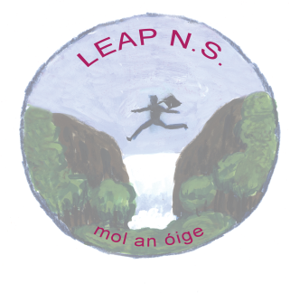

COVID-19 Policy Statement

Leap National School is committed to providing a safe and healthy workplace for all our staff
and a safe learning environment for all our pupils. To ensure that, we have developed
the following COVID-19 Response Plan. The BOM and all school staff are responsible
for the implementation of this plan and a combined effort will help contain the spread of
the virus. We will:

- continue to monitor our COVID-19 response and amend this plan in consultation
with our staff
- provide up to date information to our staff and pupils on the Public Health advice
issued by the HSE and Gov.ie
- display information on the signs and symptoms of COVID-19 and correct handwashing
techniques
- agree with staff, a worker representative who is easily identifiable to carry out the
role outlined in this plan
- inform all staff and pupils of essential hygiene and respiratory etiquette and
physical distancing requirements
- adapt the school to facilitate physical distancing as appropriate in line with the
guidance and direction of the Department of Education
- keep a contact log to help with contact tracing
- ensure staff engage with the induction / familiarisation briefing provided by the
Department of Education
- implement the agreed procedures to be followed in the event of someone
showing symptoms of COVID-19 while at school
- provide instructions for staff and pupils to follow if they develop signs and
symptoms of COVID-19 during school time
- implement cleaning in line with Department of Education advice

All school staff will be consulted on an ongoing basis and feedback is encouraged on
any concerns, issues or suggestions.

This can be done through the Lead Worker Representative, who will be supported in
line with the agreement between the Department and education partners.

Signed: Sean Mahon Date: 11th August 2020
Chairperson, Board of Management

Signed: Mary Crowley Date: 11th August 2020
Principal

